Poisson Model:
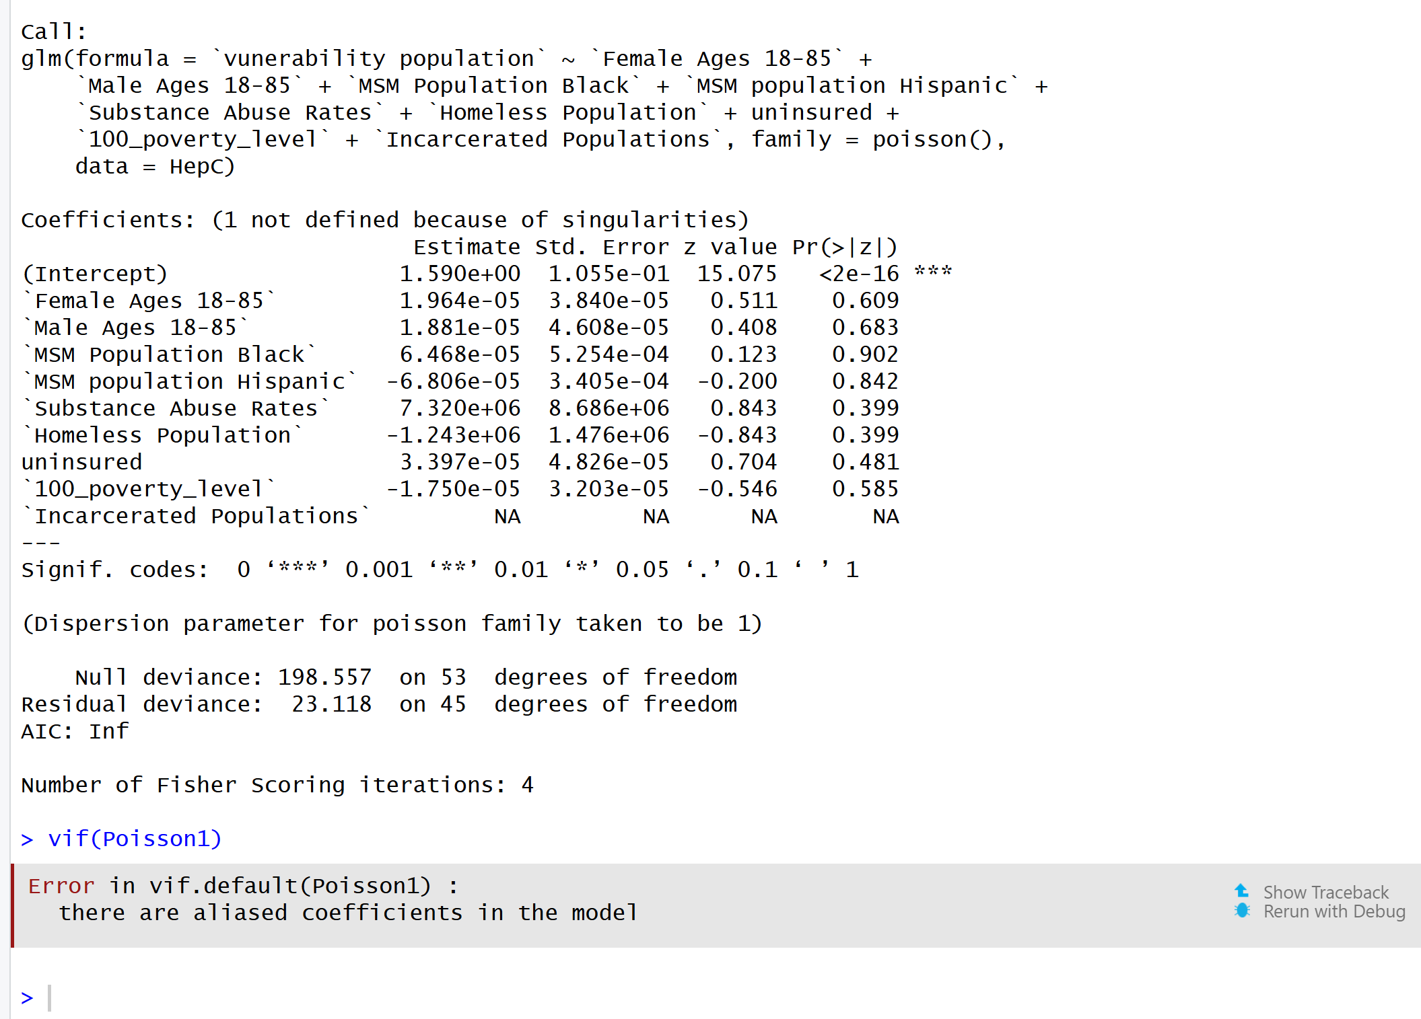
The first step of the analysis was to fit a Poisson regression model to examine the relationship between the vulnerability index and the selected demographic and socioeconomic predictors. Poisson regression is commonly used as an initial model when analyzing count-like outcomes because it assumes the dependent variable follows a Poisson distribution and allows researchers to evaluate the association between predictors and the expected outcome. However, the results indicated issues with the model. One of the variables, Incarcerated Populations, produced an NA coefficient due to singularities, meaning it was perfectly or highly correlated with other predictors in the model. This caused aliasing among coefficients, which prevented the calculation of variance inflation factors (VIF) and indicated multicollinearity among the predictors. Additionally, the AIC value was infinite, suggesting that the Poisson model did not provide a stable or appropriate fit for the data.

Negative Binomial:
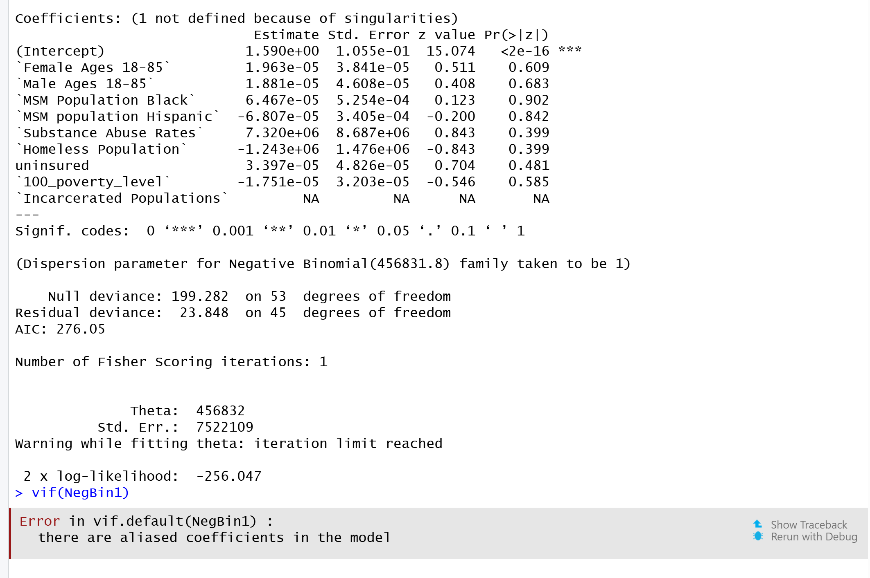
After identifying issues with the Poisson regression model, a Negative Binomial regression model was fitted as the next step to address potential dispersion problems and improve model stability. The Negative Binomial model is commonly used when the Poisson model does not adequately capture variability in the data, as it allows for greater flexibility in the variance structure. However, similar issues were observed in this model. The coefficient for Incarcerated Populations was again returned as NA due to singularities, indicating that this variable was perfectly or highly correlated with other predictors in the model. This multicollinearity caused aliased coefficients, which prevented the calculation of the Variance Inflation Factor (VIF) and suggested that the predictors were not independently contributing to the model. Because of these issues, the full Negative Binomial model was not suitable as the final model, and a stepwise backward selection procedure was then applied to identify a simpler and more stable model.

Stepwise Backward:
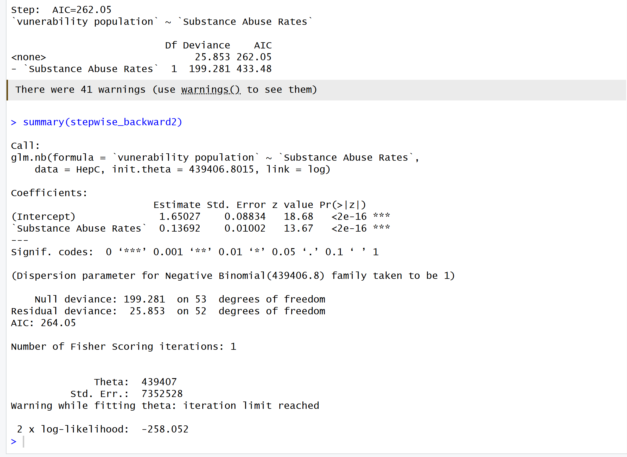
The backward stepwise Negative Binomial regression selected Substance Abuse Rates as the only significant predictor of vulnerability population. The coefficient for substance abuse rates was positive and highly significant (β = 0.1369, p < 0.001), indicating that counties with higher substance abuse rates tend to have higher vulnerable population counts. All other predictors were removed during model selection because they did not improve model fit according to the AIC criterion.
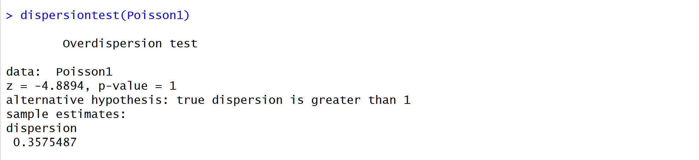
The overdispersion test checks whether the Poisson regression model has more variability in the data than the model assumes. In this output, the dispersion estimate is 0.3575, which is less than 1, and the p-value is 1, meaning there is no evidence of overdispersion in the model. This suggests that the Poisson model does not suffer from excessive variance relative to its mean, and the assumption of equal mean and variance is not violated. In simple terms, the data do not show signs of extra variability that would require a more complex model like a Negative Binomial.
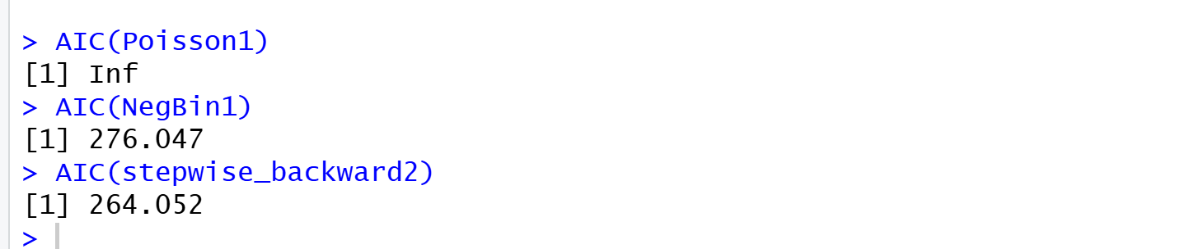
This output compares the model fit using the Akaike Information Criterion (AIC) for different models. The Poisson model shows AIC = Inf, indicating that the model did not fit properly or had numerical issues. The full Negative Binomial model has an AIC of 276.047, while the stepwise backward Negative Binomial model has a lower AIC of 264.052. Since lower AIC values indicate a better model fit, the stepwise backward model provides the best fit among the models tested. This means the simplified model selected through backward elimination explains the data more efficiently than the other models.

